**Image Annotation Tools, and Labelling Guide**

## **Using LabelImg Tool**

This LabelImg tool guide is provided by Erick Chandra and modified by Andhika

**I. App Preparation**

Open-source software for labelling images: LabelImg

**Installation:**

* **Windows**: [windows_v1.8.0.zip](https://www.dropbox.com/s/kqoxr10l3rkstqd/windows_v1.8.0.zip?dl=1)​ binary installer (recommended) or build from source
* **Linux**: - PyPi installer (recommended) or build from source

- PyPi (tested on Ubuntu 14.04 and 16.04):



* **macOS**: build from source (recommended)

**For more detailed informations regarding the installation or anything regarding the apps itself, please visit this provided link:** <https://github.com/tzutalin/labelImg>

**II. Data Collection**

* As for the image that will be used for labelling, it can be in any format but it is recommended to use the most frequent image format such as **(.jpg, .jpeg, or .png)**.

-You can gather or collect the image freely from any source such as the internet or any gadgets available to you (phones, or cameras)

**III. Image Labelling**

1. Launch the labelimg app.

* For windows user, it could be as simple as type the “labelimg” in the search column. Or type “labelimg” in the command prompt.
* As for other user such as ubuntu and mac, please refer to the link provided above for instructions on how to start the app.

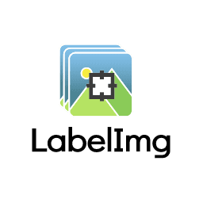

1. The image below is the user interface of labelimg. You can proceed to click the “**Open Dir**” section to open the images directory you want to be labelled on.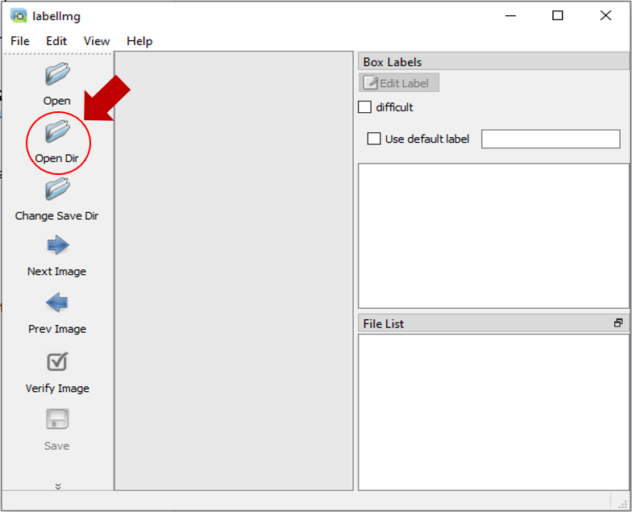
2. After you decide the directory files, the files will appear in the interface of labelimg. You can start labelling immediately by clicking the “**Create\nRectBox**”.

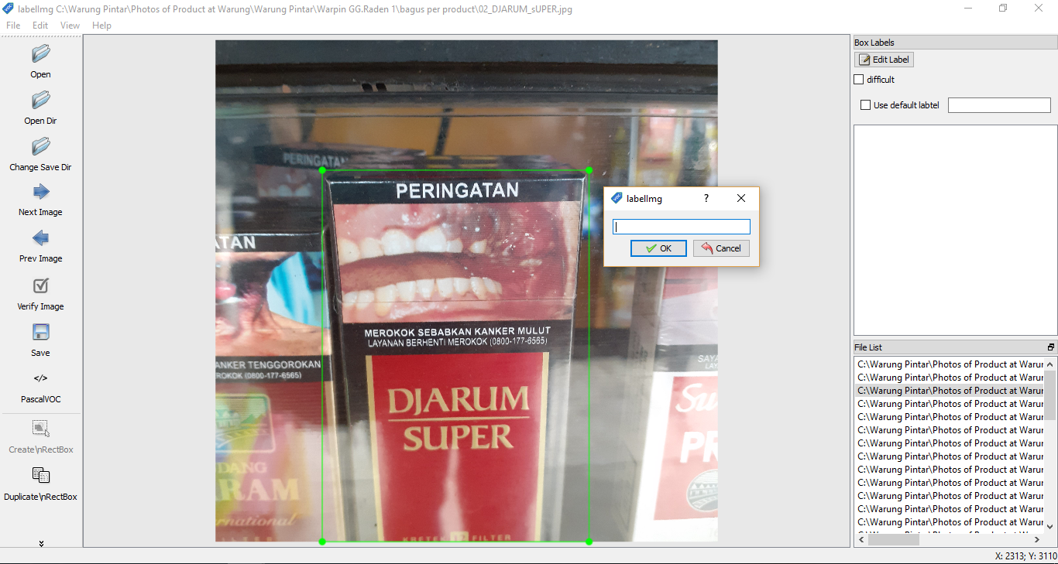

1. There will be a pop up as you can see in the image above. In that pop-up you can insert the label that you want and click ok. The label you have created will be stored in the pop-up in case you wanted to use it again for the same image.
2. It is very important to keep the consistency of the label for the same item.
3. If you have completed the image labelling, you can save the labelled image in “**PascalVOC**” format (recommended by our Brand Recognition Engineer) or in “**YOLO**” format.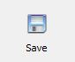
4. It is also recommended to save the files within the same folder as your keep your images to make the labelling process easier to track.

## **Using Label-Studio Tool**

This tool is discovered by our NLP engineer Ruben.

**I. App Preparation**

Before we go to the preparation, this app is not only for image annotation, but this tool is also used for many things such as text, audio labelling, even multi-task labelling which includes all of them.

* To install this tool:

**# Requires >=Python3.5**

**pip install label-studio**

**# Initialize the project in labeling_project path**

**label-studio init labeling_project**

**# Start the server at** [**http://localhost:8080**](http://localhost:8080)

**label-studio start labeling_project**

- For **Windows** :

1. You need the [lxml](https://www.lfd.uci.edu/~gohlke/pythonlibs/#lxml) wheel package that needs to be downloaded manually.
2. # Upgrade pip

pip install -U pip

1. # Assuming you are running Win64 with Python 3.8, install packages downloaded form Gohlke:

pip install lxml‑4.5.0‑cp38‑cp38‑win_amd64.whl

1. # Install label studio

pip install label-studio

- Formore detailed **information** regarding label-studio, you can visit these websites:

<https://github.com/heartexlabs/label-studio>

<https://labelstud.io/guide/index.html>

**II. Data Collection**

As this is not only a tool for image annotation, the data collection for this tool varies depending on what kind of labelling you want. The data collection for image annotation in this tool is the same with labelimg.

**III. Image Labelling**

1. Before you can start labelling, the first thing you need after starting the server is to choose the setup you want. You can choose the predefined configs and edit the config to have the label name as you want as in the pictures below:

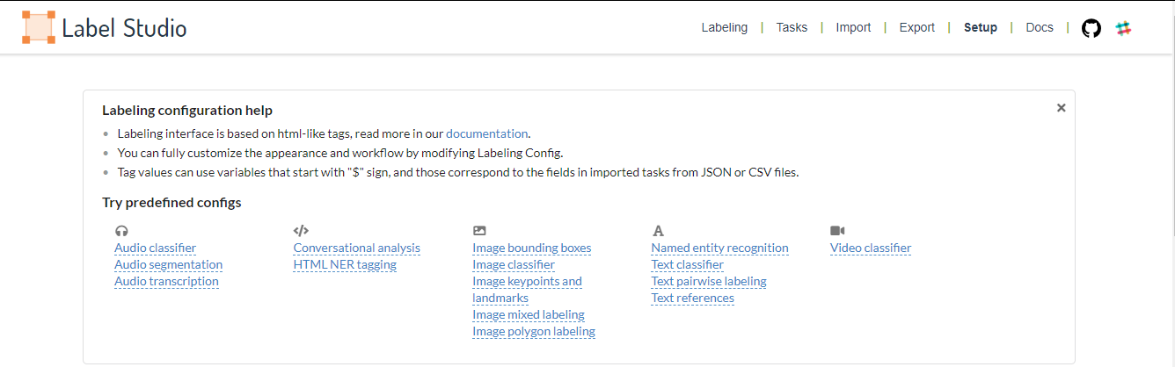

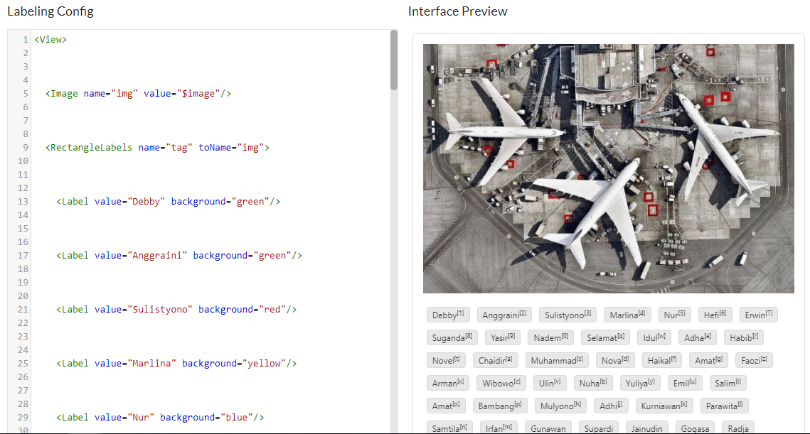

2. After you have your setup, you can now try to import the tasks (data) to the label studio. Importing the tasks (dat) is not a simple thing to do because you need to type some command line in the **command prompt.** You can see the details regarding importing tasks in the second provided link above under the “**Import tasks**” category.

3. If you have successfully imported your task, you can see how many tasks you have under the “**Tasks”** section in the user interface of Label Studio. You can see the user interface of Label Studio in the image below:

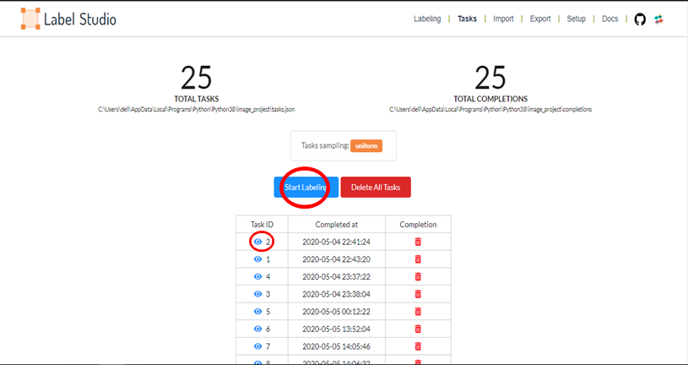

4. You can start labelling by clicking the “**Start Labelling**” button, or if you want to change the label on the image you have labelled on, you can click on the eye-like symbol.

5. After you complete all your tasks, you can proceed to the “Export” to finish your image labelling and download the files in the format you want.